Research Supplements to Promote Diversity in Health-Related Research
(Diversity Supplement
Parent Grant: Duke Pepper Older Americans Independence Center (OAIC)

Purpose of the Award
The goal of this administrative supplement is to increase diversity in aging research workforce by promoting the research and career development of an eligible investigator with a focus area on physical reserve and resilience. We will select one investigator to apply for a Diversity Supplement. The OAIC investigators will work closely with the selected applicant to develop a competitive application. The National Institutes of Aging will make the final funding decision.

Parent Grant
The Duke Pepper Older Americans Independence Center (OAIC) (NIA P30 AG028716-01) aims to promote research career development in aging research through its Core resources. The central theme of our OIAC is to understand and enhance reserve and resilience to promote recovery from stressors in late life. The three Research Cores include:
- Analysis Core, which provides statistical and technical support for projects as well as furthering statistical and analytical science.
- Molecular Measures Core, which provides comprehensive biomarkers phenotyping to characterize biochemical, metabolic and genetic bases for aging research.
- Health and Mobility Measures Core which provides expertise, devices, equipment and protocols for functional, physical and psychological measures.

Eligibility
Applicants must be a US citizen or permanent resident who is a member of a group that is under-represented in biomedical research, defined by NIH as:
  - Racial and ethnic minority groups
    - Blacks or African Americans
    - Hispanics or Latinos
    - American Indians or Alaska Natives
    - Native Hawaiians and other Pacific Islanders
  - Individuals with disabilities—physical or mental disabilities that limit major life activities
  - Individuals from disadvantaged backgrounds, defined as those who meet two or more of the following criteria:
    - Were or currently are homeless
    - Were or currently are in the foster care system
    - Were eligible for the Federal Free/Reduced Lunch Program for two or more years
    - Have/had no parents or legal guardians who completed a bachelor’s degree (see https://nces.ed.gov/pubs2018/2018009.pdf);
    - Were or currently are eligible for Federal Pell grants
    - Received support from Supplemental Nutrition Program for Women, Infants and Children (WIC) as a parent or child
    - Grew up in a U.S. designated rural area or a Centers for Medicare and Medicaid Services-designated Low-Income and Health Professional Shortage Areas
  - Particularly women in any of these groups
  - Applicants must be post-doctoral fellows, Medical Instructors, or Assistant Professors
  - PHS funded investigators are NOT eligible. PHS funded investigators include those who currently have or have received R01 and R01-equivalent grants, P01, P50 (including subproject/core leads), K01, K07, K08, K22, K23, K25, K76, K99/R00. R01-equivalent grants are defined as activity codes DP1, DP2, DP5, R37, R56, RF1, RL1, U01 and R35.
Candidates receiving pilot funds from the Duke OAIC may be considered for Diversity supplement if supplement is for non-duplicative costs.
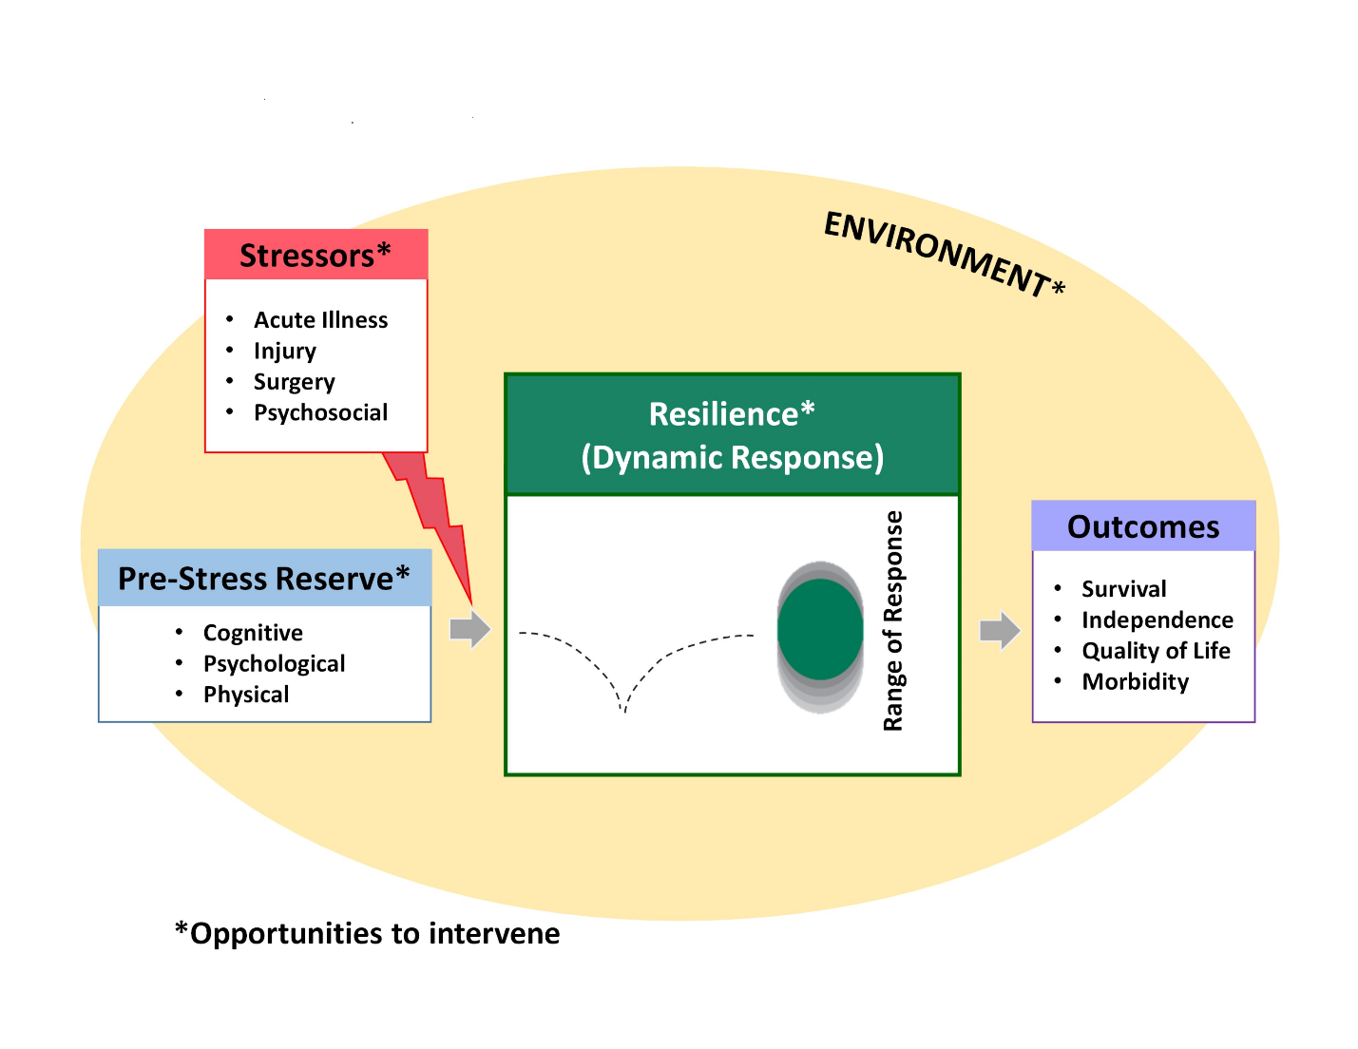
Budget and Mentorship
Supplement recipients access resources of the Duke Pepper Center at no additional costs.
For post-doctoral fellows: The NIH will provide support for salary and fringe benefits to enable the candidate to participate as a postdoctoral research associate on the funded research project. The requested annual salary must be in accordance with the salary structure of the grantee institution, consistent with the level of effort needed to complete the project. In addition, postdocs may receive up to $6,000 per year for supplies and travel.
For faculty: The requested salary and fringe benefits for an investigator should be consistent with the level of support provided by NIH Career Development Awards, and be consistent with the salary structure of the grantee institution. Effort devoted to the project is expected to be 75% (9 calendar months). Salary is capped by NIH at $75,000 plus fringe benefits. Additional funds of up to $10,000 per year may be requested for supplies and travel for the candidate.
Mentorship: Although the application will be submitted by the OAIC principal investigator, applicants may choose any primary mentor and co-mentors. Applicants are encouraged to include OAIC investigators on the mentorship team.

Duration of Award:
The expected duration of the supplement is two years.

How to Apply:
Letter of Interest (LOI) and Principal Investigator NIH Biosketch due April 4, 2022. Include the overall goals of the project with a focus on how it relates to the Duke Pepper Center theme and how the supplement will contribute to applicant’s research career development.
We will work with investigator and mentor to develop a timeline for submission of full application to NIA. Applications are reviewed on rolling basis. For additional information about full application requirements: https://www.nia.nih.gov/research/diversity-supplements
Please send materials and direct any questions to Cathleen Colón-Emeric, MD, MHS, 919 660-7517, colon001@mc.duke.edu

