**Infectious Diseases Faculty Bios**



# [Micah Thomas McClain](https://medschool.duke.edu/about-us/our-faculty/micah-thomas-mcclain)

Associate Professor of Medicine

[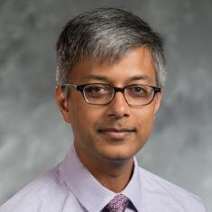](https://medschool.duke.edu/about-us/our-faculty/neeraj-k-surana)

# [Neeraj K Surana](https://medschool.duke.edu/about-us/our-faculty/neeraj-k-surana)

Assistant Professor of Pediatrics

[**Stacey Maskarinec**](https://medicine.duke.edu/profile/stacey-ann-maskarinec)  
Assistant Professor of Medicine

[**Joshua Thaden**](https://medicine.duke.edu/profile/joshua-thomas-thaden)

Associate Professor of Medicine